University Of Bristol A Cappella Society - Committee Meeting Minutes - Meeting 2
N5

In Attendance:

Alisha Agarwal - Publicity

Aaliyah Butt - President

James Bantick - Treasurer

James Kerr - Resources

Wilfred Kemsley - Secretary

- Apologies:
Ayesha Chauhan - Social Sec

Godfrey Yu - Gig Coordinator

Isabel Fraser - Vice-President

Ken De Leon - Equality’s Officer
`
Apologies also for these boring minutes as this was a virtual meeting at 10 in the morning

Apologies for putting this meeting on at 10 in the morning that's also my bad

- Action Update:
ACTION (ALL) - fill out committee introduction form for social media
ACTION (WILF) - create whentomeet for next meeting.
ACTION (Alisha) - consider format and creation of new flyers for freshers fair and beyond. Information includes voice parts, hours and audition times. Also pursue tote bags.
ACTION (Izzy, Aaliyah, Ken, James K) have a meeting about room bookings.
ACTION (Izzy, Aaliyah, Ken, James K) have a meeting about room bookings.
ACTION (Ayesha) create plan for freshers bar crawl as first social of the year
ACTION (ALL) - Check out summer plans documents and get to know what you need to do.
ACTION (ALL) - Next meeting, bring budget proposals if you want one and suggestions on how to make the family scheme as effective as possible
ACTION (KEN) creates a calendar for key equalities dates throughout the year.
ACTION (JAMES K) write terms of use contract for amp
ACTION (AALIYAH, IZZY, GODFREY) have meeting about bosw as it needs to be booked next week
ACTION (Aaliyah, Ken, Ayesha) have a meeting about the family scheme
ACTION (James B/James K) Create an invoice template and then create the three invoices required for Mic hire - see last meeting for the three groups.
ACTION (Ken, Izzy, Aaliyah, James B, Jess) meeting to discuss helping individual groups run for a grant.
ACTION (Jess) Please share the information on grants too Aaliyah and James B
ACTION (WILF) create group chats as instructed by Aayliah
ACTION (JAMES B) PAY ATTENTION YOU PRICK

- General update:
- Room bookings have been discussed the minutes are available on the committee drive

- We have sorta re-affiliated and sent off our applications for the welcome fair - we will not hear back for a month or so.

- James K and Aayliah have discussed the amp - every term a form will go out for people to book it, form on the inside of the storage cupboard to ensure responsibility if it is taken. Group managers will sign a contract. Minutes also on the committee drive
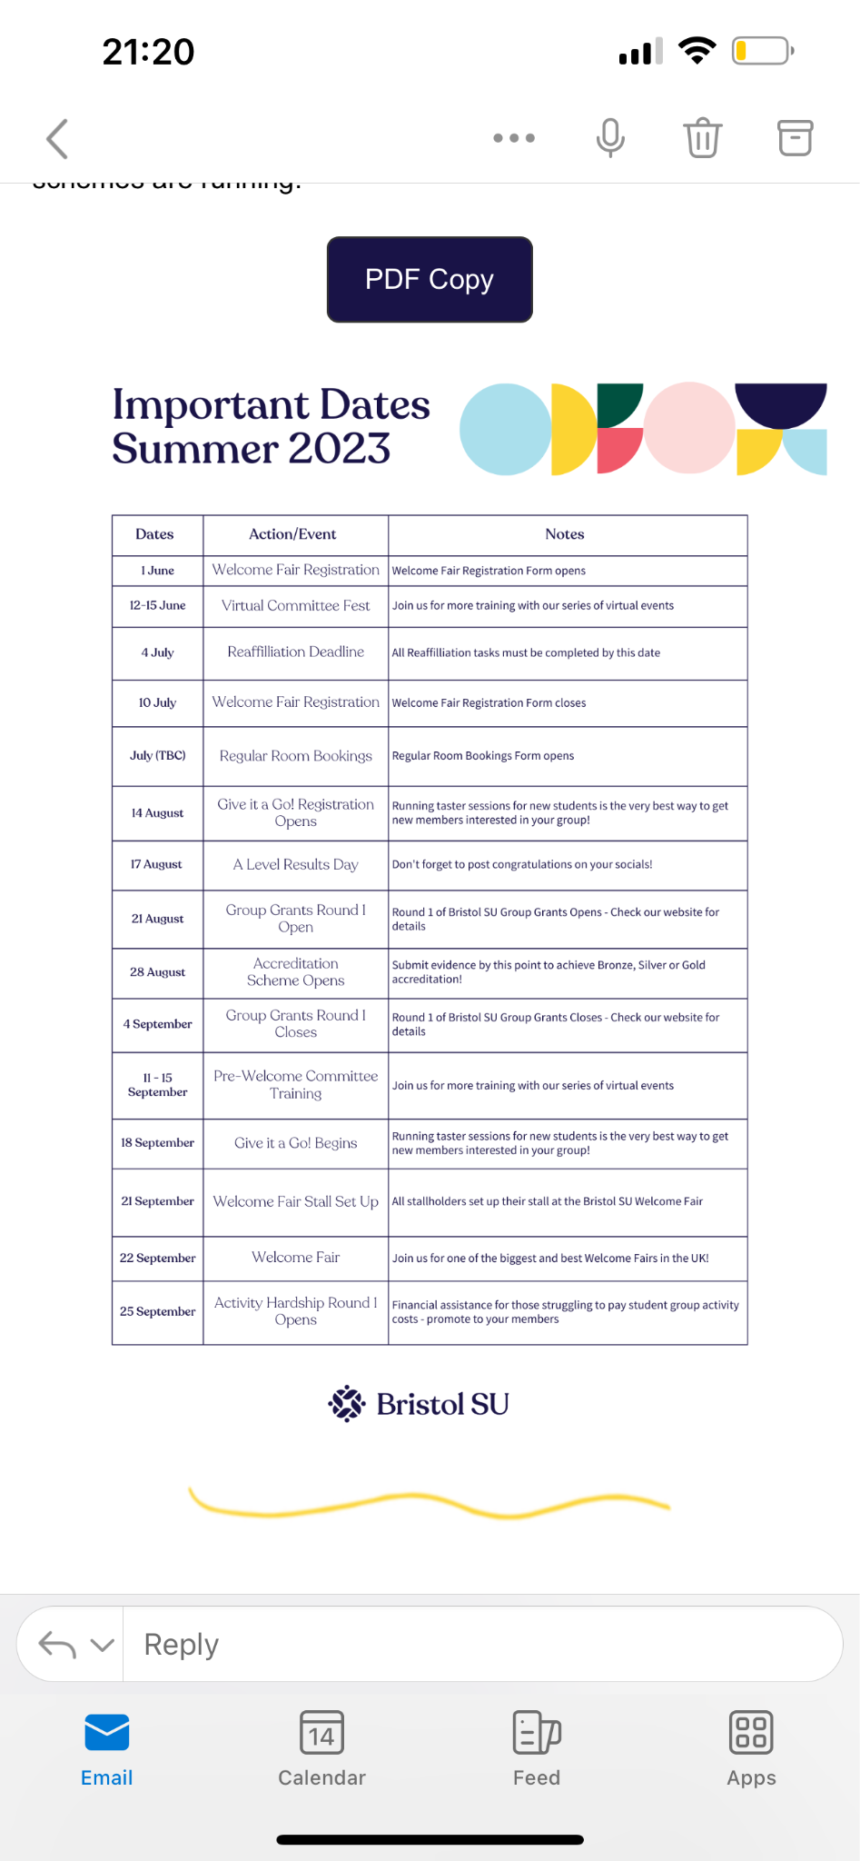
- Key Dates

- Gold Balloon:
- We have completed 4 points so far, but we cannot submit these so early, but well done.

- Treasure Updates/Budgets:
James presented rough numbers of how much money we might have to start the year.
- Bosw and bosw social - £1.5 K for both the social and marketing of this specific event.

- Socials generally - total budget set at around £3.5 K. This is around just over a grand for the big events - christmas ball, summer ball and bosw.

- Marketing - £250 for the welcome fair and recruitment currently available. £500 for merch!
- Resources - it's unlikely money will be spent unless we decide to purchase specific recruitment but they do have a budget.

James B also completely clocked out after doing this update so thanks mate :/

- SU grants:
- We qualify for 3 grants - the £3K main committee grant, the £3K Alumni Grant and the sustainability grant.

- Main committee grant must be used in three months - money must be unattainable without the grant - most societies don't ask for the full fund - It's to be used to ‘enrich’ the society - receipts must be perfect or we are in trouble - We need to write a very clear and solid application (perhaps for a workshop?)

- Alumni grant - also up to £3K. We ask for these grants in order to fund one specific thing within the society. Meeting created to discuss helping individual groups apply. Possible a tour?...

- There is also a sustainability grant which we should use as it also aids our gold balloon application. The gold ballon talk that Aaliyah attended created some good ideas - (clothes swap? Veganuary? Fashion show?)

- Family Scheme:
- General consensus is to keep the family scheme the same but Kids come from the same group but parents are not - parents still sign up together but not compulsory

- The ‘fix’ is to keep encouraging socials that revolve around the family scheme. Also important that we ensure the kids can interact with the parents through some form of social media

- First Social
- It's not going to be the pub crawl, as we should wait for all groups to have their new members to do it instead.

- We will stick with the mingle in the balloon bar - still very social.

- Publicity Check:
- Merch budget could be spent on tote bags for freshers fair and flyers to promote events. It might not be as expensive as the budget set.

- Ideas on what to do in order to promote a cappella at freshers fair include playing our music or doing a karaoke stall.

- Intro posts are nearly done!

- AOB:
- Possible MTB Collab in Winston (48 Hour But A Cappella?) Songs should be musical theater - might be hard to teach but let's wait and see.

- Competition Committees have been decided

- Academy - GM: Ken MD: Torin and Ben
- Pitch FIght - GM: Aaliyah MD: Aashna
- Suspensions - GM: Niamh MD: Emma

- Jess got arrested lol

- The rest of the committee left to go and get drunk

- Aalyiah states she wishes to go ‘do the rounds’. No slut shaming in this committee.

